## 



**JOMO KENYATTA UNIVERSITY**

**OF**

**TECHNOLOGY AND AGRICULTURE.**

**Crop Water Productivity Estimation for Resilient Agriculture Using Remote Sensing and Machine Learning Approaches**

By

**ALFRED AMBOKA - ENC221-0099/2018**

COLLEGE OF ENGINEERING AND TECHNOLOGY,

SCHOOL OF CIVIL ENGINEERING AND GEOSPATIAL ENGINEERING,

DEPARTMENT OF GEOSPATIAL ENGINEERING AND GEOSPATIAL INFORMATION SYSTEMS.

**2023.**

## Introduction

### 1.1 Background

Agriculture is the backbone of many economies, providing food and livelihoods for millions of people worldwide. However, the increasing demand for food coupled with the effects of climate change has put a strain on water resources leading to water scarcity in many regions. Water scarcity refers to the limited availability of freshwater resources to meet the demands of various sectors, including agriculture. This is a significant challenge that affects agricultural production and food security in many regions of the world (Booker & Trees, 2020). Agriculture fully depends on water which can be both rainfed or irrigated. Estimation of water used and yield produced is therefore necessary. This is enhanced through crop water productivity.

Crop water productivity ( CWP ) is generally defined as crop yield per cubic meter of water consumption or the ratio of yields to evapotranspiration during the growing season

(Hellegers et al., 2008; Gao et al., 2023). Crop water productivity estimation is a crucial aspect of precision agriculture, which aims to optimize the use of agronomic inputs like water, pesticides, and fertilizers to meet the growing demand for food while minimizing the use of natural resources like land and fresh water. The productivity of crops can vary depending on whether they are grown in rain-fed or irrigated agriculture systems.

Irrigated agriculture accounts for an estimated 70% of total freshwater withdrawals worldwide, and in many drier countries, agricultural water use accounts for more than 90% of total withdrawals (Scheierling & Tréguer, 2018). As water becomes increasingly scarce, the management of agricultural irrigation moves to the center of water management concerns. Without advances in management and more integrated policy-making in developed and developing countries, water scarcity, and related water problems will significantly worsen over the next several decades. The transition from an expansionary water economy to a maturing water economy has led to the need for more efficient water use in agriculture. The concept of water productivity, which denotes the relationship between marketable yield and the seasonal water use by the plant through evapotranspiration, is an important indicator to express the resource use efficiency and can provide an assessment of crop performance under different irrigation strategies (Hommadi & Almasraf, 2019). Rain-fed agriculture, on the other hand, is characterized by low average yields compared to irrigated agriculture, as rainfall rarely meets the time with the required amount of water application for plant growth. The performance of rain-fed productivity remains low and stable for most crops, and crop production is undulating under rain-fed agriculture. In many countries, rain-fed areas are the critical cultivation areas with the largest concentration of rural poverty spanning several agroecological regions. The low efficiency of water use and management in agriculture is a major challenge and one of the contributing factors to low crop productivity and balance is drought.

Estimations of CWP are affected by drought conditions. Therefore, understanding the climatic conditions of the region of interest is paramount while carrying out such studies. According to Sarshad et al., 2021, drought is the greatest environmental stress in arid and semiarid regions which has restricted agricultural development. Those agricultural activities that have to survive in such areas are exposed to extreme temperatures, variations in rainfall, long solar radiation hours, and so on. Kenya is particularly vulnerable to drought due to its geography and climate. Several droughts are common in agricultural lands in Kenya and most tropical regions. The different types of drought, their severity, and their impacts depend on various factors, such as the duration, intensity, and spatial extent of the drought event. Meteorological drought is the most common type of drought, which occurs when there is a prolonged period of below-average precipitation. Agricultural drought refers to the impact of meteorological drought on crop production, while hydrological drought is characterized by low water availability in rivers, lakes, and groundwater. As drought impact on agriculture influences crop evapotranspiration (ET) and general yield obtained hence the need to look into how to manage available water resources for maximum production in drought conditions. This brings us to why CWP has established itself as a recognized indicator for evaluating the progress being made toward SDG 6.4, which calls for much greater water usage efficiency (Blatchford et al., 2018; Ghorbanpour et al., 2022).

The level of CWP estimation varies with scale, including at the farm level, and regional level. The robustness of such estimation is influenced by several factors including data and the extent of the study area. Farm-level estimation is challenging and is limited in one way considering the high volume of estimation data required when performing time series estimation. Traditionally, estimating CWP has relied on labor-intensive and time-consuming field-based methods, such as lysimeters and soil moisture sensors. These methods are often limited in spatial coverage and cannot provide real-time data for large-scale agricultural areas. Moreover, they may not account for spatial variations in soil moisture and crop water requirements within a field. This has given way to the use of remote sensing for crop water productivity estimations. Remote sensing can help estimate actual evapotranspiration (ET) and crop yield, which are important factors in CWP estimation ( Ghorbanpour et al., 2022; Gao et al., 2023). This is important for improving regional agricultural water use efficiency and water conservation levels. Finally, remote sensing coupled with machine learning has been on the rise in many fields including agriculture and water use efficiency estimation.

Machine learning is becoming an increasingly popular tool for estimating crop water productivity. Existing methods of machine learning continue to prove to be more reliable through data fusion and the combination of several models (Elbeltagi et al., 2022). On remote sensing data for farming, many machine learning algorithms have been applied, including random forests (RFs), support vector machines (SVMs), artificial neural networks (ANNs), genetic algorithms (GAs), and ensemble learning (Virnodkar et al., 2020; Sadri et al., 2022). Particularly in geographic classification and remote sensing data prediction, RF applications have gained popularity for resolving data overfitting (Sadri et al., 2022; Vergopolan et al., 2021; Saini and Ghosh, 2018). Although machine learning has been used in many fields such as yield estimation (Islam et al., 2023), and weather forecasting (Patel et al., 2021) together with remote sensing, it is underutilized in crop water productivity estimation. The variation is from the global level to the country and local level. Therefore, this study focuses on CWP estimation at the local level and specifically in irrigation schemes in the eastern part of Kenya - Bura Tana River Scheme.

The Bura Irrigation Scheme covers 5,360 hectares. However, only 3,340 ha are being irrigated due to insufficient water availability. However, additional water might be made available to irrigate more areas and boost the poor output of corn. Currently, the plan produces 3.5 t ha-1 of commercial and 4.4 t ha-1 of seed maize. This is less than the 4.9 t ha-1 average for the entire world value. Accurate water management in this area is therefore essential and proper estimates of how water is used and yield produced will be of importance. The use of machine learning coupled with remote sensing will allow proper mitigation measures to be applied. Therefore, CWP estimation is necessary to boost production while withstanding drought conditions and help reduce the growing water scarcity levels.

### 1.2 Statement of the problem

One of the significant challenges in agricultural systems particularly in irrigation schemes in Kenya is the limited availability of water resources. Water scarcity continues to increase due to the impact of climate change. According to the UN 2022 report, over 85% of the wetlands on our planet have been lost for over 300 years. The problem of the water crisis has been made worse by factors such as water contamination, population increase, urbanization, and inadequate management of water resources. Therefore, food security is going to be impacted by water shortage (Mulwa et al., 2021). On the other hand, drought continues to rage in the land of Kenya resulting in reduced agricultural land and affecting agricultural production, especially in the supply of water for production.

The physiological and biochemical processes of plants are predicted to be affected by soil water stress, which is a major barrier to agricultural production, particularly in arid and semi-arid lands (ASALs) (Muli et al., 2015; Mbayaki, 2021). By managing crops and water poorly, plant quality and yields may be harmed (Fan et al., 2012; Mbayaki, 2021).

Accurate estimation of CWP requires comprehensive data on crop growth, soil moisture, and water availability. However, obtaining such data is challenging and often needs to be improved in the Bura Irrigation Scheme. Existing methods of water productivity being used are limited and the data being used is a major contribution to this effect. Bura Irrigation scheme being among the largest in Kenya has faced low records of yield production as outlined by Muigai et al, 2019. The scheme relies on water from river Tana which is 50 km away. Over the recent years, the river Tana water level has been reducing due to drought effects upstream. This impact the supply of water for agricultural purpose downstream including the Bura Irrigation scheme. In such scenarios, it becomes crucial to optimize water use efficiency to ensure sustainable and resilient agriculture. However, conventional irrigation practices often result in inefficient water use and lower crop water productivity. There is a need to address this problem by developing methods to estimate and improve crop water productivity by utilizing remote sensing (RS) and machine learning techniques. By accurately assessing water requirements and usage patterns, effective water management strategies can be devised to enhance agricultural productivity while conserving water resources.

### 1.3 Justification

Water scarcity continues to rage in arid and semi-arid lands due to drought. Bura Irrigation scheme which is within agro-ecological zone V (semi-arid to arid) obtains its water from the Tana River which is 50 km away by pumping to lift water from the river (National Irrigation Authority, 2023). In addition, the area experiences low rainfall of about 400mm. High Temperatures are experienced all year round with little seasonal variation. Mean maximum temperatures never fall below 31°C and average minimum temperatures are above 20°C. All these factors make the agricultural area more vulnerable and costly, especially in the case of water pumping to meet crop water needs in the area. Water Crop water productivity is a crucial requirement for increased agricultural production because crop water is needed to substitute for water loss by transpiration and soil evaporation (Mbayaki, 2021).

Over the recent years, food insecurity has affected many parts of Kenya with Eastern and Northern regions being highly affected. According to the Integrated Food Security Phase Classification (IPC), 2023, an estimate of around 4.4 million people in ASALs are facing acute food insecurity. Generally in Kenya, acute food insecurity has affected around 37% of the population between 2022 to 2023 and is expected to increase. Food insecurity continues to rise with increasing agricultural drought events, rapid population growth, water pollution reducing water use for agricultural purposes, and high demand that strains available water resources. In addition, Kenya declared In September 2021, the East African state of Kenya drought emergency. The affected drought areas (ASALs) continually received low rainfall for the season between November and December (International Committee of the Red Cross, 2022) leading to low agricultural production. With all these cases of drought events, agricultural production can be optimized to survive in the face of water scarcity to boost productivity by managing available water resources. CWP serves as the best alternative for the estimation of crop productivity in existing irrigation schemes and may serve as a near real-time decision-making tool on water management to increase agricultural production hence an increase in food security.

### 1.4 Research Identification and Objectives

The main objective is to estimate crop water productivity using remote sensing and machine learning techniques which can help support irrigation management and improve agricultural resilience.

Specific objectives  include:

* To estimate maize yield and determine evapotranspiration (ET) values based on analyzed maize crop phenological period in the study area
* To estimate maize crop water productivity and analyze the spatial distribution of CWP and yields,
* To develop machine learning models for predicting crop water productivity (CWP) for maize crops and identify the best-performing machine learning models for CWP estimation in the study area.

### 1.5 Study Outline

This research study is divided into 6 chapters whereby the first chapter introduces

the study by detailing the background, statement of the problem, justifying the problem, and objectives; Chapter 2 contains the reviewed literature which relates to this topic. Further, Chapter 3 shows the data and methods used in the study with Chapter 4 highlighting the results for the findings from the methods. Chapter 5 discusses the findings and finally, Chapter 6 concludes and recommends future research that might not be addressed at this level of geoscientific exploration and expertise

## **Literature review**

### 2.1 Water Use (WU/WUE), and Water Productivity

Crop water productivity (CWP), which aims to maximize possible yields per unit of water consumed in both rain-fed and irrigated agricultural production, is a key concept in agronomy. CWP may be achieved by maximizing the use of rainwater in the soil, increasing crop marketable yields per unit of transpired water, and minimizing water loss from the soil water balance (Mbayaki, 2021). Water use and water use efficiency all refer to CWP and are frequently used synonymously.

Crop water productivity (CWP) plays an important role in irrigated agriculture for food and environmental security, especially when water becomes scarce (Bekchanov et al., 2011). The estimations have been accomplished in past studies with the help of crop models. Crop modeling is an efficient approach for estimating WP and plays a significant role in addressing water management strategies (Soomro et al., 2019). Commonly used crop models for maize include CERES-Maize (Crop EnvironmentResource Synthesis), SWAT, SWAP (Soil Water Atmosphere Plant), AQUACROP, CROPWAT, and more. The CERES-Maize model (Cuculeanu et al., 2002), is specifically designed to simulate the growth, development, and yield of maize (corn) crops under different agroclimatic and management conditions. It has been widely used to assess crop water productivity for maize and to study the impact of water management strategies on maize production (Kisekka et al., 2017; Sen et al., 2023 ). The model incorporates a comprehensive water balance approach, which takes into account various water inputs and outputs for the maize crop. These inputs include rainfall, irrigation, and soil water content, while outputs include evapotranspiration (ET) and drainage losses. By simulating the water balance, the model estimates how efficiently the maize crop uses water to produce yield. Nonetheless, other crop models can accurately estimate crop water productivity, such as the FAO AquaCrop model. The AquaCrop model simulates attainable yields of major herbaceous crops as a function of water consumption under rainfed, supplemental, deficit, and full irrigation conditions. Similarly, the model has been widely used to assess water productivity (Mostafa et al., 2023; Shan et al., 2023). Additionally, some studies have proposed a combined method for the estimation of spatial and temporal variation of crop water productivity under deficit irrigation scenarios based on the AquaCrop model (Ahmadpour et al., 2022)

### 2.2 Crop Water Productivity Estimation

The CWP estimation is achieved by the ratio of yield and actual evapotranspiration (ETa) (Talpur et al., 2023; Yihun et al., 2013).

The phenological period, which refers to the different stages of crop growth and development, plays a crucial role in estimating ET and crop yield (Gao et al., 2023). Factors such as crop coefficient (Kc) and harvest index (HI), which vary during different phenological periods, are considered in the estimation of ET and yield. Different crops have varying crop phenology growing period, quantity harvested, and crop response to the environmental condition influences crop yield. Crop transpiration is calculated by multiplying the reference evapotranspiration (ETo) with a crop coefficient (KcTr). According to FAO, the crop coefficient is proportional to canopy cover and varies throughout the life cycle of a crop. It is affected by water stress, which can affect canopy development and induce stomata closure, thereby directly affecting crop transpiration. A study carried out by Gao et al., 2023, utilized the dry matter mass–harvest index, crop Kc based on crop phenology to map crop water productivity of maize and wheat to be 1.60 kg/m3 and 1.39 kg/m3 respectively in the area of study.

The evapotranspiration (ET) formula is used to estimate the amount of water used by crops. The ET formula takes into account various factors such as temperature, humidity, wind speed, and solar radiation. The Penman-Monteith equation is a widely used ET formula that is recommended by the Food and Agriculture Organization (FAO) of the United Nations. The Penman-Monteith equation is a combination of energy balance and aerodynamic resistance equations and is considered the most accurate method for estimating ET. Wang et al., 2023, and Hassan et al., 2022 and more employed the ET formula in the estimation of evapotranspiration which is an important component of CWP estimation.

To estimate the crop water productivity of maize, several studies have been conducted using different methods and models. A study carried out in Mexico used locally developed crop coefficient curves and United Nations Food and Agriculture Organization (FAO) crop coefficients to estimate maize water use and water productivity. The study found that maize actual evapotranspiration varied with year and ranged from 634.2 to 697.7 mm by the local Kc curve, from 687.3 to 739.3 mm by the non-adjusted FAO Kc values, and from 715.8 to 779.6 mm with the FAO adjusted Kc values. One study proposed an ensemble approach for identifying the virtual water content (VWC) of main crops on the Korean Peninsula in past and future climates. The ensemble VWC is calculated using three types of crop yields and fifteen consumptive amounts of water use in the past and the future (Lim et al., 2017). The study found that while the ensemble VWC of rice and maize was 1.18 m3 kg−1 and 0.58 m3 kg−1, respectively, in the past, the future amounts were estimated at 0.76 m3 kg−1 and 0.48 m3 kg−1, respectively. The yields of both crops showed a decline in future projections, indicating that this change could have a positive impact on future water demand.

#### CWP Estimation Methods

Estimation methods vary depending on the region and the crops being cultivated. They are mainly grouped into field-based, modeling and simulation, and remote sensing and machine learning methods. Every method has its advantages and disadvantages.

##### Surface Energy Balance Algorithm (SEBAL)

SEBAL has proven to be a valuable tool for water resource management, agricultural planning, and environmental monitoring, providing reliable estimates of evapotranspiration and surface energy fluxes over large areas. It has been widely adopted in various research and operational applications worldwide due to its ability to utilize freely available satellite data and provide valuable information for water-scarce regions. The Surface Energy Balance Algorithm (SEBAL) is a method used to estimate evapotranspiration (ET) using remote sensing and the energy balance principle (Gibson et al., 2013). It was developed to analyze thermal infrared remote sensing data from satellites, such as the Landsat series, to monitor and manage water resources and agriculture efficiently. Souza et al., 2023 carried out a study that focused on estimating the evapotranspiration of irrigated açaí plants in eastern Amazonia using SEBAL. The results showed good agreement with the Bowen ratio method, and SEBAL was found to be useful for irrigation management and reducing water losses. Similarly, Gao et al, 2023; Kamyab et al., 2022; Bansouleh et al., 2015; Pachac Huerta & Chavarri Velarde, 2019 and more recently used this model in the estimation of evapotranspiration proved to be more efficient. SEBAL is limited for accurate evapotranspiration Estimation. SEBAL relies on spatial information, such as land surface temperature and vegetation indices, which can vary across different areas. This spatial dependence can introduce uncertainties in the estimation of evapotranspiration. This is due to the reliance on anchor pixels. Prakash Mohan et al., 2019, properly outline the limitation of anchor pixels. Another limitation of this Algorithm is wind speed observation SEBAL requires accurate wind speed data for calculating the dry/wet endpoints of each pixel. However, wind speed observations are known to have high temporal and spatial variations and may not be routinely available, especially in heterogeneous areas.SEBAL is sensitive to vegetation parameters, such as the Normalized Difference Vegetation Index (NDVI), which is used to estimate the fraction of vegetation cover. Inaccurate or incomplete vegetation information can affect the accuracy of SEBAL estimates (Ruhoff et al., 2012).

Surface Energy Balance System (SEBS) is another remote sensing-based algorithm used to estimate evapotranspiration (ET) and surface energy fluxes from satellite data. It was developed to overcome some limitations of the Surface Energy Balance Algorithm (SEBAL) and provide more accurate and physically based estimates of surface energy fluxes and ET. Similar to SEBAL, there are discrepancies in the reported accuracy of the SEBS model due to known model sensitivities. Its performance may vary depending on the input data quality and the specific characteristics of the study area. SEBS requires accurate vegetation parameters to be obtained, especially in agricultural areas where accurate vegetation parameters can be obtained, high-resolution imagery with low sensor zenith angles is available, and canopy cover is complete

This requirement may limit the applicability of SEBS in areas where such data is not readily available (Gibson et al., 2013).

##### Field-Based Methods

Several field estimation methods can be used to improve CWP, including lysimeter measurement, nuclear techniques, modeling approaches, field observations, and genetic enhancement. Lysimeter measurement and nuclear techniques have been used to improve water management, saving water by reducing the loss of components that are not used by the plants and thus enhancing water productivity (WP) (Abou Zakhem et al., 2019). These techniques involve measuring soil water content, evaporation, and deep percolation to determine the amount of water used by plants and the amount lost to the environment. However, this method is limited at a small scale.

Field observations can also be used to estimate CWP. A study done by Shoukat et al., 2021, investigated the effects of deficit irrigation and fertilizer levels on wheat crop yield, yield parameters, nutrient use, and water use efficiencies. The study followed a randomized complete block design of three replications, taking three irrigation treatments according to the requirement of crop estimated by the CROPWAT model (100% of ETC), deficit irrigation (80% of ETC), and deficit irrigation 60% of ETC and three nitrophenols fertilizer treatments at different growth stages. A commonly used field method for CWP estimation is the harvest method. The harvest method involves measuring the crop yield and the amount of water used for irrigation, and then calculating the crop water productivity (CWP) as the ratio of yield to water use. This method provides a direct measure of the productivity of a crop in terms of water use efficiency. The method faces limitations of extent especially for large spatial areas, and data availability, especially for the amount of water lost. Field-based methods may not be equally applicable to all crop types as different crops have diverse water requirements, growth patterns, and responses to water. In addition, CWP can change over time due to climate variability, seasonal fluctuations, and other factors. Field-based methods might provide only a snapshot of CWP for a specific period, limiting their ability to capture long-term trends.

##### Remote sensing and Machine learning Approaches.

Remote sensing is a technique used to estimate crop water productivity by analyzing data collected from a distance, such as satellite imagery. This method has become increasingly popular in recent years due to its ability to support management, monitoring, and controlling activities at different spatial and temporal scales (Dalla Marta et al., 2018). Remote sensing has revolutionized the way we monitor and estimate crop water productivity (CWP) by providing valuable data on crop health, water stress, and environmental conditions over large agricultural areas. With the ability to gather information from satellites, drones, and other airborne platforms, remote sensing techniques have become essential tools for sustainable water management in agriculture. Li et al., 2008; Talpur et al., 2023, Gao et al., 2023, Spiliotopoulos et al., 2023 and Darwish et al., 2023 successfully utilized remote sensing technologies in the estimation of crop water use and productivity.

The use of remote sensing indices is utilized to estimate crop water productivity. Commonly used indices include NDVI (Mohanasundaram et al., 2022; Pandya et al., 2023; Farrell et al., 2018), EVI (Jaafar & Ahmad, 2015; Tang et al., 2015), NDWI (Singh et al., 2021; Wang et al., 2009) and TVDI (Holzman & Rivas, 2016) and more. NDVI is one of the most widely used remote sensing indices for assessing vegetation health. It quantifies the density of green vegetation and indicates plant vigor and growth. NDVI values close to +1 indicate healthy, thriving vegetation, while values closer to -1 indicate stressed or sparse vegetation. By monitoring NDVI over time changes in crop water productivity can be inferred. EVI is an improvement on NDVI, designed to reduce atmospheric influences and improve sensitivity at high vegetation densities. It provides a more accurate representation of vegetation conditions, making it suitable for areas with dense vegetation cover or during periods of high atmospheric interference. TVDI combines thermal infrared data with NDVI to assess water stress in crops. It uses the difference between daytime land surface temperature and the potential temperature under non-water-stressed conditions. TVDI is beneficial for monitoring crop water status, especially in regions where water scarcity is a concern.

Machine learning (ML) techniques on the other have been increasingly employed in the agricultural field to improve the accuracy and efficiency of crop water productivity estimation. This technique has proven to be more efficient in crop yield prediction (Ashwitha & Latha, 2022), water demand forecasting (Emami et al., 2022), remote sensing and Image analysis (Thapa et al., 2023), drought monitoring and mitigation, precision Irrigation, and agriculture. Machine learning techniques offer powerful tools to analyze complex datasets, predict crop water requirements, and enhance water productivity in agriculture.

Despite the use of remote sensing and machine learning in crop water productivity estimation, they also have limitations. The limitation may be due to data availability and quality. Remote sensing relies on data from satellites and other sensors, and the availability and quality of this data can vary. Cloud cover, sensor malfunctions, and limited satellite revisit frequency can lead to gaps in data, making it challenging to get consistent and timely information for accurate estimations. Another limitation is spatial and temporal resolution. The spatial resolution of remote sensing data may not be sufficient to capture small-scale variations within fields or individual plants. Similarly, the temporal resolution may not always be high enough to capture rapid changes in crop water needs, especially in rapidly evolving weather conditions. Finally, the complexity of the crop-water relationship poses a major challenge in accurate water productivity estimation. The relationship between crop water productivity and remote sensing parameters is complex and influenced by various factors like crop type, stage of growth, and weather conditions. Capturing these complex interactions in a single model can be challenging.

## **Materials and Methods**

### 3.1 Study Area

The Bura irrigation scheme is the study area located in Tana River County (1°11'39.1S, 39°50'23.0"E). The scheme is one of the largest and oldest irrigation projects in Kenya. It was established in the 1978s and covers an area of about 12,000 acres gazetted area and 10,000 acres under irrigation. The primary water source is from River Tana which is 50 km away and maize is the main crop grown in the area. Other crops grown in the area include Green grams, cowpeas, cotton, watermelon, sugarcane, and onions.

Low and erratic rainfall patterns characterize the scheme. The average annual rainfall in the region is relatively low, ranging from 200 to 600 millimeters (8 to 24 inches). The rainfall is highly variable, with the most precipitation occurring during the short rainy season from March to May and a shorter second rainy season from October to December. Drought periods are standard, and rainfall distribution can vary significantly from year to year.

Due to the arid conditions, evapotranspiration rates are relatively high in the Bura irrigation scheme. High temperatures and low humidity contribute to increased evapotranspiration rates, which can impact water availability for crops.

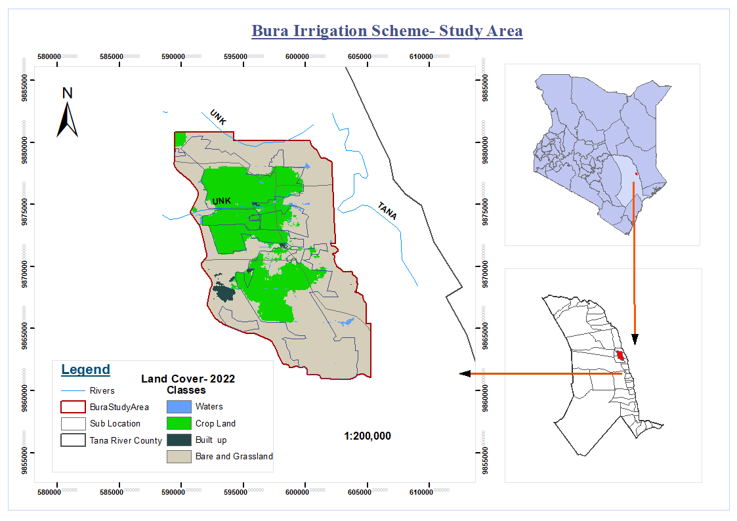

Figure 3.1: Study area map

### 3.2 Data

This study utilizes both remote sensing and ground-based data for both crop yields and climate-related data. Remote sensing data were acquired from the Google Earth Engine using Python API for five years between 2018 and 2022 with the main focus being during the growing seasons.

#### 3 .2.1 Meteorological Data

The availability of consistent, long, and complete time series of meteorological data is critical for estimating crop water requirements because weather is the most important input variable for assessing crop evapotranspiration which determines soil water deficit. This study used the ERA5 daily Grided dataset and the local meteorological station dataset. ERA5 is the fifth generation ECMWF reanalysis of the previous eight decades' worth of global climate and weather data. Data is accessible beginning in 1940 to date (Copernicus, 2018). The dataset contains basic atmospheric meteorological factors such as air temperature, pressure, and wind at various altitudes, as well as surface parameters such as rainfall and sea parameters such as sea-surface temperature and wave height. The daily homogenized, filtered,

reviewed, and pre-processed (outliers removed) data of minimum temperature (Tmin),

maximum temperature (Tmax), mean temperature (Tmean), Precipitation, incoming solar radiation, vapor pressure, and wind speed ( u - component at 10m high above the ground) were acquired from Google Earth Engine (GEE) data catalog for a period of five years; between 2018 to 2022. In the case of vapor pressure, the information may not be directly available in the ERA5 dataset. However, it was estimated using atmospheric parameters such as air temperature and relative humidity as previously done by Pelosi et al., 2022 on crop water requirement studies.

Similarly, daily weather data for the Garissa weather station was acquired from Kenya Meteorological Department on request. This was for the same period and it was used as part of the ground validation data together with the collected yield data. More accurate data could be acquired at the exact field level and in several locations but this was limited in this study.

#### 3.2.2 Optical Satellite Imagery Datasets

In this study, several optical datasets were acquired from the GEE platform including MODIS, Landsat 8, and Sentinel 2 datasets. MODIS provided high temporal resolution data of up to daily with an average 8-day temporal resolution being provided. Three surface reflectance products were used for the purpose of data fusion. In this case, MOD09A1.061 Terra Surface Reflectance 8-Day Global 500m product, USGS Landsat 8 Level 2 Collection 2 Tier 1 and Sentinel-2 MSI - MultiSpectral Instrument Level-2A dataset were accessed from the GEE data catalog using Python API. Landsat 8 dataset has a spatial resolution of 30m, and sentinel 2 has the B2 - B4 and B8 having a spatial resolution of 10m. To achieve a harmonized resolution, resampling was performed on the datasets to achieve a 10m spatial resolution.

Table 3.1 below summarizes the data used in this study.

| **Data** | **Description/Resolution** | **Source** |
| --- | --- | --- |
| Potential evapotranspiration (PET ) | 500m | MODIS |
| Temperature (Tmin, Tmax), Incoming Solar solar radiation, vapor pressure, Wind speed, and Precipitation | From ERA5_Land Daily Dataset and  Actual Meteorological Local Station Data. | ECMWF/  KMD (Kenya Meteorological  Department) |
| EVI | 500m | MODIS |
| Soil Moisture | 1-Month | GLDAS |
| Evapotranspiration (ET) | 8-Days at 500m resolution | MODIS |
| Surface reflectance( Derived Dataset: NDVI, SAVI, EVI, etc.) | 10m - Fused dataset | Sentinel 2, Landsat 8 OLI, MODIS |

### 

### 3.3 Methodology Framework

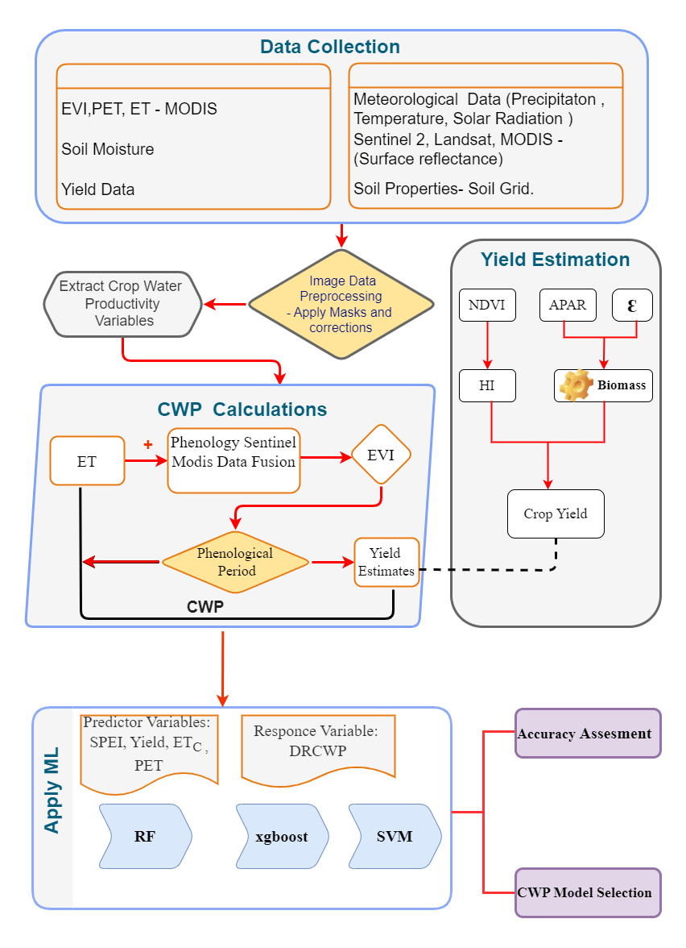

Figure 3.2: Flowchart

### 3.4 Data Fusion and Indices Calculation

#### 3.4.1 Daily Imagery Dataset

The increased availability and diversity of global satellite products, as well as the rapid development of new algorithms, has opened up huge opportunities for the creation of new levels of data with varied geographical, temporal, and spectral resolutions (Dhillon et al., 2023). MODIS has a short return interval, and the data quality is consistent. However, because of the limited spatial resolution, it isn't applicable to the small-scale region. Sentinel-2 and Landsat 8 data have a better spatial resolution of about 10m and 30m lowest value for some bands than MODIS data, although the data quality is unreliable.

The implementation of the fusion algorithm for the three datasets was based on a method used by Gao et al., 2023 by extending the formula used with one for Landsat. However, several fusion algorithms do exist. An example is the improved spatial and temporal data fusion approach (ISTDFA) used by Wu et al., 2018 to fuse MODIS and Landsat. Another algorithm used was STAIR 2.0 for the fusion of MODIS, Sentinel 2, and Landsat. Similar other common algorithms are the Spatial and Temporal Adaptive Reflectance Fusion Model (STARFM) and two extended data fusion models (STAARCH and ESTARFM) that have been used to fuse MODIS and Landsat data (Gao et al., 2015). In this study, the fusion algorithm utilized the formula provided below to obtain a daily 10 m resolution dataset.

{"mathml":"<math style=\"font-family:stix;font-size:16px;\" xmlns=\"http://www.w3.org/1998/Math/MathML\"><mstyle mathsize=\"16px\"><msub><mo largeop=\"true\">V</mo><mi>H</mi></msub><mfenced><msub><mi>t</mi><mi>i</mi></msub></mfenced><mo>&#xA0;</mo><mo>=</mo><mo>&#xA0;</mo><msub><mo largeop=\"true\">V</mo><mi>M</mi></msub><mfenced><msub><mi>t</mi><mi>i</mi></msub></mfenced><mo>&#xA0;</mo><mo>+</mo><mo>&#xA0;</mo><mo largeop=\"true\">K</mo><mstyle displaystyle=\"false\"><mo>.</mo><mstyle displaystyle=\"true\"><mfrac><mrow><munderover><mo>&#x2211;</mo><mrow><mi>j</mi><mo>=</mo><mn>1</mn></mrow><mi>n</mi></munderover><mfenced open=\"[\" close=\"]\"><mrow><mi>&#x3C9;</mi><mfenced><mrow><msub><mi>t</mi><mi>i</mi></msub><mo>,</mo><msub><mi>t</mi><mi>j</mi></msub></mrow></mfenced><mfenced><mrow><msub><mo largeop=\"true\">V</mo><mi>T</mi></msub><mfenced><msub><mi>t</mi><mi>j</mi></msub></mfenced><mo>-</mo><msub><mo largeop=\"true\">V</mo><mi>M</mi></msub><mfenced><msub><mi>t</mi><mi>j</mi></msub></mfenced></mrow></mfenced></mrow></mfenced></mrow><mrow><munderover><mo>&#x2211;</mo><mrow><mi>j</mi><mo>=</mo><mn>1</mn></mrow><mi>n</mi></munderover><mi>&#x3C9;</mi><mfenced><mrow><msub><mi>t</mi><mi>i</mi></msub><mo>,</mo><msub><mi>t</mi><mi>j</mi></msub></mrow></mfenced></mrow></mfrac></mstyle><mo>+</mo></mstyle><mspace linebreak=\"newline\"/><mo>&#xA0;</mo><mo>&#xA0;</mo><mspace linebreak=\"newline\"/><mo>&#xA0;</mo><mo>&#xA0;</mo><mo>&#xA0;</mo><mo>&#xA0;</mo><mo>&#xA0;</mo><mo>&#xA0;</mo><mo>&#xA0;</mo><mo>&#xA0;</mo><mo>&#xA0;</mo><mo>&#xA0;</mo><mo>&#xA0;</mo><mo>&#xA0;</mo><mo>&#xA0;</mo><mo>&#xA0;</mo><mo>&#xA0;</mo><mo>&#xA0;</mo><mo>&#xA0;</mo><mo>&#xA0;</mo><mo>&#xA0;</mo><mo>&#xA0;</mo><mo>&#xA0;</mo><mo>&#xA0;</mo><mo>&#xA0;</mo><mo>&#xA0;</mo><mo>&#xA0;</mo><mo>&#xA0;</mo><mo>&#xA0;</mo><mo>&#xA0;</mo><mo>&#xA0;</mo><mo>&#xA0;</mo><mo>&#xA0;</mo><mo>&#xA0;</mo><mo>&#xA0;</mo><mo>&#xA0;</mo><mo largeop=\"true\">K</mo><mstyle displaystyle=\"false\"><mo>.</mo><mstyle displaystyle=\"true\"><mfrac><mrow><munderover><mo>&#x2211;</mo><mrow><mi>k</mi><mo>=</mo><mn>1</mn></mrow><mi>m</mi></munderover><mfenced open=\"[\" close=\"]\"><mrow><mi>&#x3C9;</mi><mfenced><mrow><msub><mi>t</mi><mi>i</mi></msub><mo>,</mo><msub><mi>t</mi><mi>k</mi></msub></mrow></mfenced><mfenced><mrow><msub><mo largeop=\"true\">V</mo><mi>L</mi></msub><mfenced><msub><mi>t</mi><mi>k</mi></msub></mfenced><mo>-</mo><msub><mo largeop=\"true\">V</mo><mi>M</mi></msub><mfenced><msub><mi>t</mi><mi>k</mi></msub></mfenced></mrow></mfenced></mrow></mfenced></mrow><mrow><munderover><mo>&#x2211;</mo><mrow><mi>k</mi><mo>=</mo><mn>1</mn></mrow><mi>n</mi></munderover><mi>&#x3C9;</mi><mfenced><mrow><msub><mi>t</mi><mi>i</mi></msub><mo>,</mo><msub><mi>t</mi><mi>k</mi></msub></mrow></mfenced></mrow></mfrac></mstyle></mstyle></mstyle></math>","truncated":false} (1)

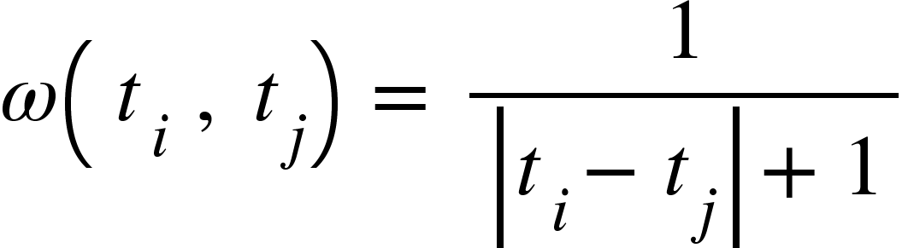 (2)

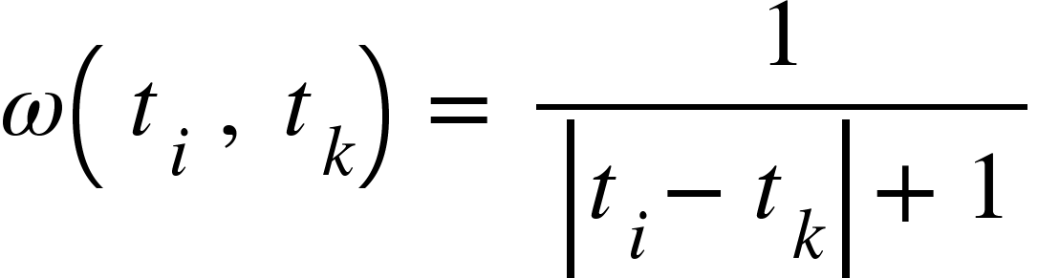 (3)

Where:

* () - Value of the fused image pixel at time
* () - Value of the MODIS image pixel at time
* () - Value of the Sentinel-2 image pixel at time ()
* () - Value of the Landsat 8 image pixel at time
* N - Number of Sentinel-2 images
* M - Number of Landsat 8 images
* - Day of Year (DOY) corresponding to the MODIS data.
* - DOY corresponding to the Sentinel-2 data
* - DOY corresponding to the Landsat 8 data.
* ω() - Weight of the Sentinel-2 image at time
* ω() - Weight of the Landsat 8 image at time
* K - Empirical coefficient accounting for the influence of missing Sentinel-2 and Landsat 8 images on data fusion.

The fusion process involved data preprocessing like performing atmospheric corrections on the Landsat 8 images, and Sentinel 2 images. Cloud masking and filtering were performed to ensure that cloud-free images are obtained for fusion. This methodology adopted a procedure utilized by Luo et al., 2020 in the actualization of the STAIR 2.0 algorithm. This involved cloud removal, and resembling for MODIS dataset from 500m to 30m spatial resolution and fusing MODIS with Landsat as shown in equation (1) above. Similarly, atmospheric corrections, co-registration, and cloud removal and filtering were performed on the Sentinel-2 dataset which was then fused with resampled 10 m resolution MODIS-Landsat 8 dataset to 10 m resolution daily dataset between 2018 to 2022.

Figure 3.2 shows a sample NDVI map comparing the output from the fused dataset and coarse 500m resolution MODIS NDVI for the period between January and December 2022. This help to achieve both high spatial and temporal resolution for the fused dataset to ensure improved crop monitoring and metric generation within the study area.

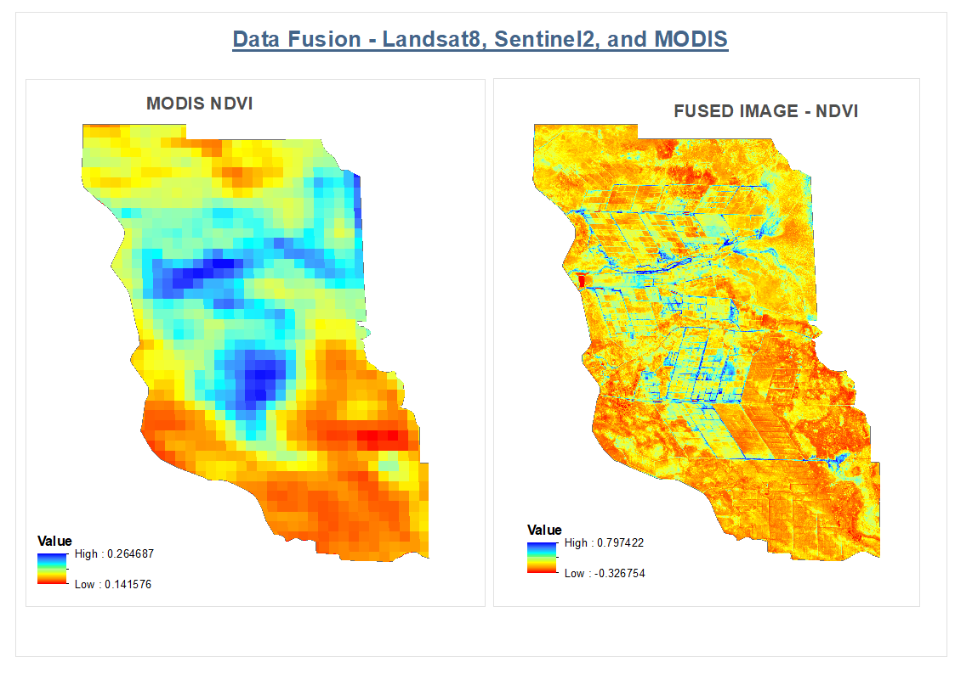

Figure 3.3: Sample NDVI from the fused Daily Dataset.

#### 3.4.2 Indices

The study calculated several indices to support the analysis of CWP and machine learning modeling. The indices are categorized into drought-based, vegetation-based, soil-based, and water-based indices. They include NDVI, VCI, and more.

Table 3.2 below summarizes all the indices used in the study.

| Indices | Expression | Use Case/ Reference |
| --- | --- | --- |
| NDVI | (NIR - Red) / (NIR + Red) | (Dhau et al., 2019; Bolfe et al., 2023) |
| EVI | 2.5 * ((NIR - Red) / (NIR + 6 * Red - 7.5 * Blue + 1)) | (Dhau et al., 2019) |
| GNDVI | (NIR - Green) / (NIR + Green) | (Dhau et al., 2019) |
| MSAVI | (2 * NIR + 1 - sqrt((2 * NIR + 1)^2 - 8 * (NIR - Red))) / 2 | (Dhau et al., 2019) |
| MNDWI | (Green- SWIR)/ (Green + SWIR) | (Agilandeeswari et al., 2022; Laonamsai et al., 2023) |
| EDI | (PET - ET) / PET | (Khan et al., 2017) |
| VCI | (NDVIi - NDVImin)/(NDVImax - NDVImin) | (Zhao et al., 2022; Sánchez et al., 2016) |
| TCI | (LSTmax - LSTi)/(LSTmax - LSTmin) | (Zhao et al., 2022; Sánchez et al., 2016) |
| SMCI | (SMi - SMmin)/(SMmax - SMmin) | (Zhao et al., 2022; Sánchez et al., 2016) |

### 3.5 Crop Yield

Yield calculation based on remote sensed data is achieved by determining total dry matter biomass and harvest index. Harvest index is a key agricultural term that relates to crop plants capacity to convert photosynthetically fixed carbon into edible yield which is frequently the crop's harvested component such as grains, fruits, or vegetables. Combined product of harvest index and summation of biomass results to yield estimate. In this case, Biomass-Harvest index method is used. Harvest index method is inherited from study by (Moriondo et al., 2007 )

HI = (4)

Where:

HI - Actual Harvest index for C4 crop (maize/corn)

- Maximum harvest index for maize. In C4 crops have been choosen to be 60% (0.6)

- The range selected is 0.2 for C4 crops.

- The mean value of NDVI between flowering and maturity

- The mean value of NDVI between planting and flowering for maize crop.

Dry matter Biomass estimation utilizes NDVI values and solar radiation as major input parameters. According to Bastiaanssen & Ali, 2003, Biomass can be estimated using the following formula.

Biomass = (0.864 x x APAR) (5)

Where:

is the light use efficiency (LUE). and APAR is the 24 hour absorbed photosyntetically active radiation (). APAR is given as shown;

APAR = 0.48 x f x S (6)

Where f refer to the APAR fraction which changes with respect to leaf area index. S Represent the incoming solar radiation. This component is obtained from weather data. The value of 0.48 is an average or typical value that has been found to represent the efficiency of plants in converting PAR into chemical energy through photosynthesis. Its is also important to note that PAR value describes the total amount of radiation available for photosynthesis assuming leaves intercept all sunlight. This is a very speculative estimate since leaves both transmit and reflect solar radiation.

Determination of the fraction of APAR ( f ) depends of vegetation indices of crop at a specific point in time. In this case, NDVI is specifically used as main index in the calculation of fraction of APAR. Given by the expression;

f = -0.161 + 1.257 (7)

Another important component in the determination of Biomass is the LUE. LUE quantifies the plants' *efficiency* in utilizing solar radiation for photosynthetic carbon fixation. Given by the expression;

= x g(T) x g(D) x (8)

represent the max value for C4 crops like corn/maize. A study determined to be approximately 2.5 (Huang et al., 2022). Similarly, g(D) accounts for vapour pressure and g(T) accounts for crop heat stress. Both g(T) and g(D) and scalar quantities. Finally, represents the water stress mainly obtained as an evaporative fraction.

Utilizing results from biomas and harvest index (HI), yield is then obtained by the following expression;

Yield (Y) = Biomass x HI (10)

### 3.6 Evapotranspiration (ET) Estimation

## **Results**

### 4.1 Crop Phenology

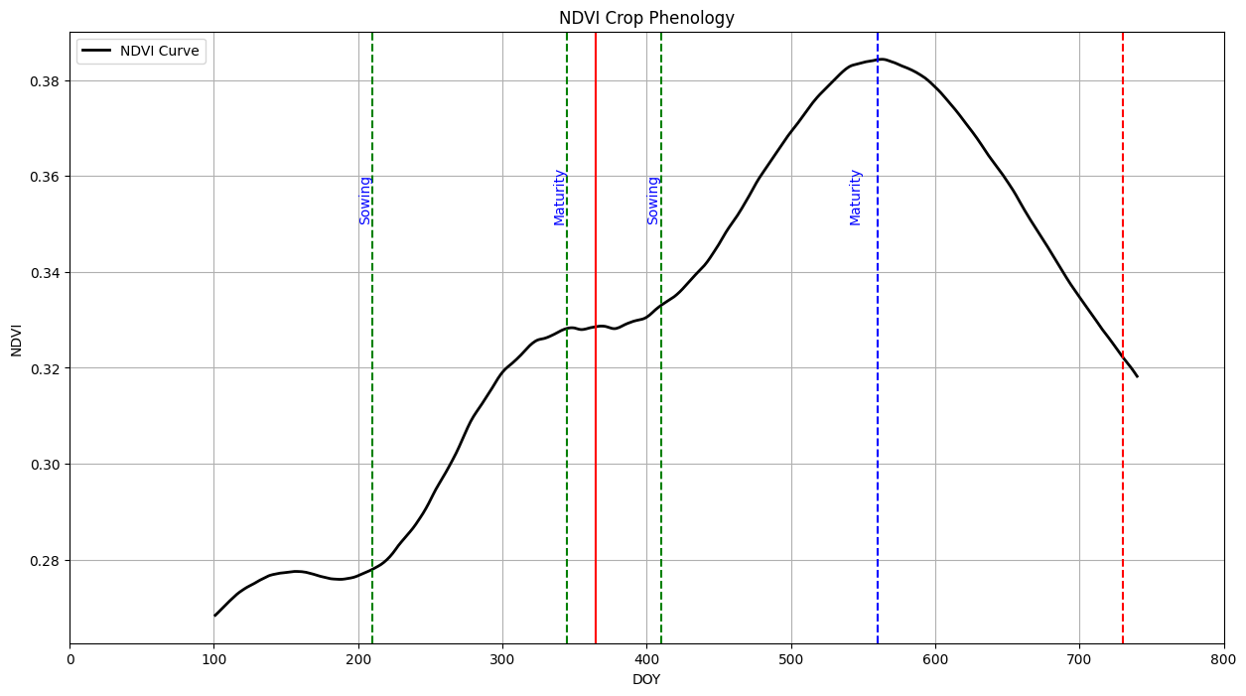

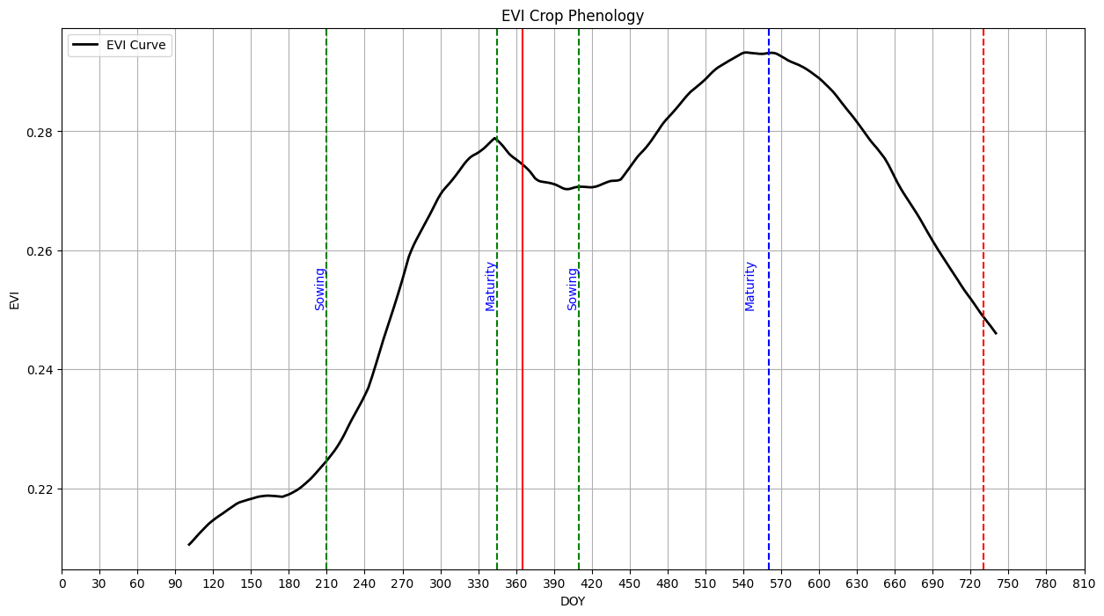

### 4.3 Yield Estimation

#### 4.3.0 Classification

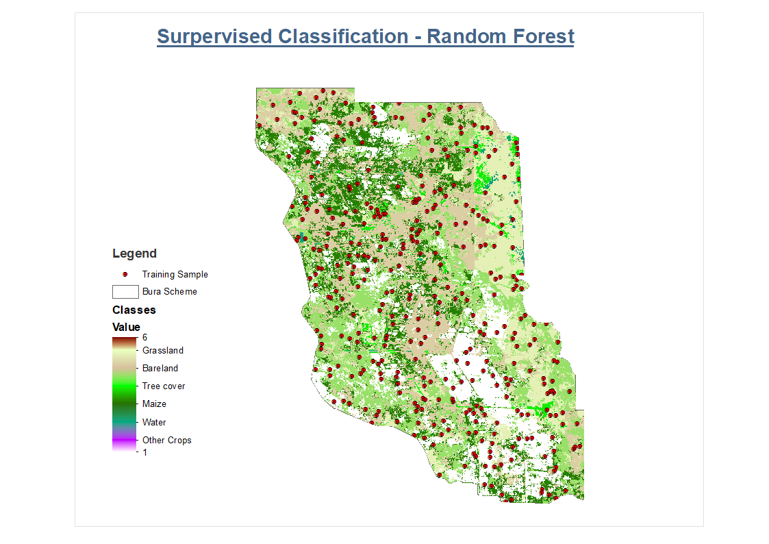

#### 4.3.1 Vegetation distribution

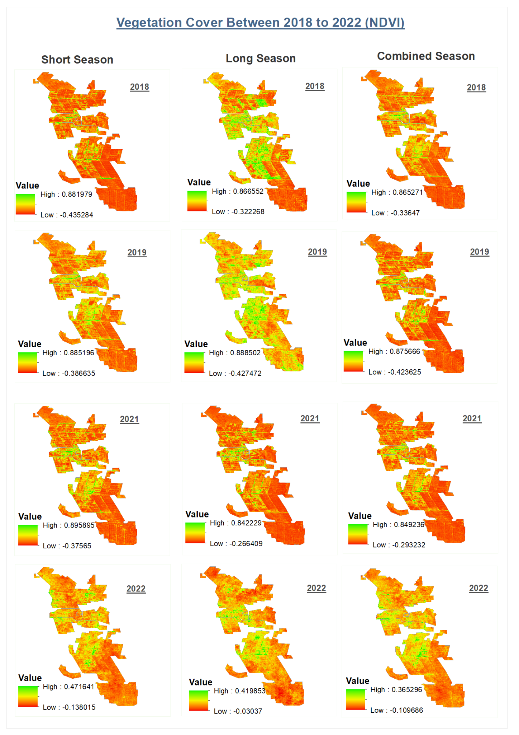

#### 4.3.2 Seasonal Yield Distribution

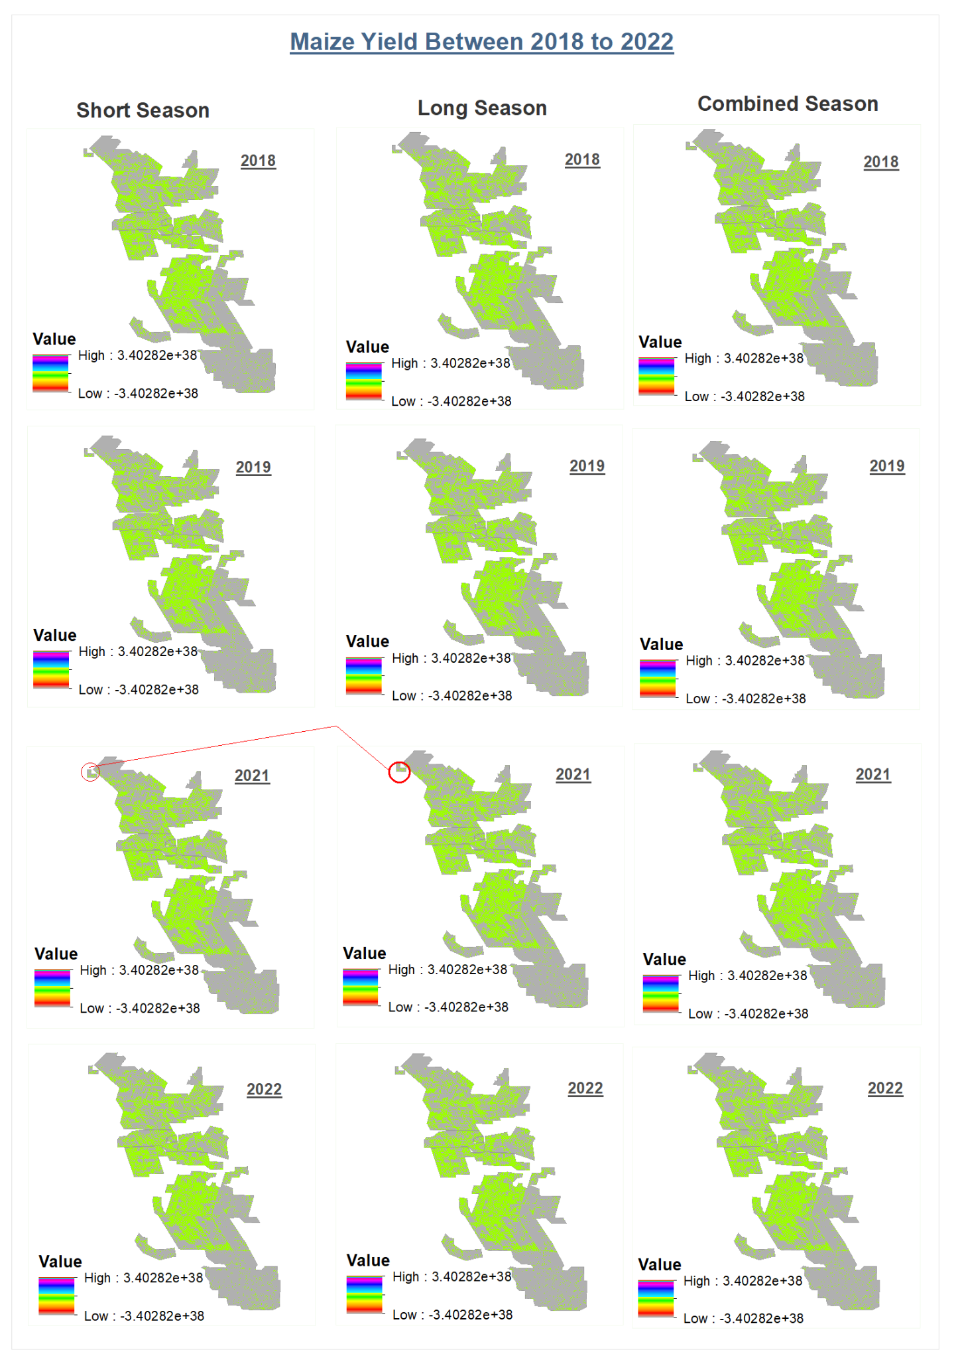

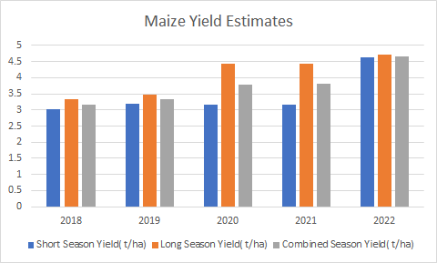

| **Year** | **Short Season Yield**  **( t/ha)** | **Long Season Yield**  **( t/ha)** | **Combined Season Yield**  **( t/ha)** |
| --- | --- | --- | --- |
| 2018 | 3.014488319 | 3.321803621 | 3.16814597 |
| 2019 | 3.179032183 | 3.479721725 | 3.329376954 |
| 2020 | 3.151177879 | 4.434757818 | 3.792967849 |
| 2021 | 3.155689042 | 4.442808604 | 3.799248823 |
| 2022 | 4.63217413 | 4.714734856 | 4.673454493 |

## References

Huang, L. *et al.* (2022) ‘A two-stage light-use efficiency model for improving gross primary production estimation in Agroecosystems’, *Environmental Research Letters*, 17(10), p. 104021. <https://doi.org/10.1088/1748-9326/ac8b98> .

Bastiaanssen, W.G.M. and Ali, S. (2003) ‘A new crop yield forecasting model based on satellite measurements applied across the Indus Basin, Pakistan’, *Agriculture, Ecosystems &amp; Environment*, 94(3), pp. 321–340. <https://doi.org/10.1016/s0167-8809(02)00034-8>.

Moriondo, M., Maselli, F. and Bindi, M. (2007) ‘A simple model of regional wheat yield based on NDVI data’, *European Journal of Agronomy*, 26(3), pp. 266–274. <https://doi.org/10.1016/j.eja.2006.10.007> .

Dhau, I., Dube, T., & Mushore, T. D. (2019). Examining the prospects of sentinel-2 multispectral data in detecting and mapping maize streak virus severity in smallholder Ofcolaco farms, South Africa. *Geocarto International*, *36*(16), 1873–1883. <https://doi.org/10.1080/10106049.2019.1669724>

Laonamsai, J., Julphunthong, P., Saprathet, T., Kimmany, B., Ganchanasuragit, T., Chomcheawchan, P., & Tomun, N. (2023). Utilizing NDWI, MNDWI, Savi, WRI, and Awei for estimating erosion and deposition in Ping River in Thailand. *Hydrology*, *10*(3), 70. <https://doi.org/10.3390/hydrology10030070>

Bolfe, É. L., Parreiras, T. C., Silva, L. A., Sano, E. E., Bettiol, G. M., Victoria, D. de, Sanches, I. D., & Vicente, L. E. (2023). Mapping agricultural intensification in the Brazilian savanna: A machine learning approach using harmonized data from Landsat Sentinel-2. *ISPRS International Journal of Geo-Information*, *12*(7), 263. <https://doi.org/10.3390/ijgi12070263>

Agilandeeswari, L., Prabukumar, M., Radhesyam, V., Phaneendra, K. L., & Farhan, A. (2022). Crop classification for agricultural applications in hyperspectral remote sensing images. *Applied Sciences*, *12*(3), 1670. <https://doi.org/10.3390/app12031670>

Khan, M. I., Liu, D., Fu, Q., & Faiz, M. A. (2017). Detecting the persistence of drying trends under changing climate conditions using four meteorological drought indices. *Meteorological Applications*, *25*(2), 184–194. <https://doi.org/10.1002/met.1680>

Sánchez, N., González-Zamora, Á., Piles, M., & Martínez-Fernández, J. (2016). A new soil moisture agricultural drought index (SMADI) integrating Modis and smos products: A case of study over the Iberian Peninsula. *Remote Sensing*, *8*(4), 287. <https://doi.org/10.3390/rs8040287>

Zhao, Y., Zhang, J., Bai, Y., Zhang, S., Yang, S., Henchiri, M., Seka, A. M., & Nanzad, L. (2022). Drought monitoring and performance evaluation based on machine learning fusion of multi-source remote sensing drought factors. *Remote Sensing*, *14*(24), 6398. <https://doi.org/10.3390/rs14246398>

Gao, F., Hilker, T., Zhu, X., Anderson, M., Masek, J., Wang, P., & Yang, Y. (2015). Fusing Landsat and Modis data for vegetation monitoring. *IEEE Geoscience and Remote Sensing Magazine*, *3*(3), 47–60. <https://doi.org/10.1109/mgrs.2015.2434351>

Wu, M., Huang, W., Niu, Z., Wang, C., Li, W., & Yu, B. (2018). Validation of Synthetic Daily Landsat NDVI time series data generated by the improved spatial and temporal data fusion approach. *Information Fusion*, *40*, 34–44. <https://doi.org/10.1016/j.inffus.2017.06.005>

Luo, Y., Guan, K., Peng, J., Wang, S., & Huang, Y. (2020). Stair 2.0: A generic and automatic algorithm to Fuse Modis, landsat, and sentinel-2 to generate 10 m, daily, and cloud-/gap-free surface reflectance product. *Remote Sensing*, *12*(19), 3209. <https://doi.org/10.3390/rs12193209>

Dhillon, M. S., Kübert-Flock, C., Dahms, T., Rummler, T., Arnault, J., Steffan-Dewenter, I., & Ullmann, T. (2023). Evaluation of modis, Landsat 8 and sentinel-2 data for accurate crop yield predictions: A case study using STARFM NDVI in Bavaria, Germany. *Remote Sensing*, *15*(7), 1830. <https://doi.org/10.3390/rs15071830>

Pelosi, A., Belfiore, O. R., D’Urso, G., & Chirico, G. B. (2022). Assessing crop water requirement and yield by combining ERA5-land reanalysis data with CM-SAF satellite-based Radiation Data and sentinel-2 satellite imagery. *Remote Sensing*, *14*(24), 6233. <https://doi.org/10.3390/rs14246233>

Copernicus, E. (2018, June 14). *Copernicus Climate Data Store*. Copernicus Climate Data Store |. <https://cds.climate.copernicus.eu/cdsapp#!/dataset/reanalysis-era5-single-levels?tab=overview>.

Thapa, B., Lovell, S., & Wilson, J. (2023). Remote Sensing and machine learning applications for aboveground biomass estimation in agroforestry systems: A Review. *Agroforestry Systems*, *97*(6), 1097–1111. <https://doi.org/10.1007/s10457-023-00850-2>

Emami, M., Ahmadi, A., Daccache, A., Nazif, S., Mousavi, S.-F., & Karami, H. (2022). County-level irrigation water demand estimation using Machine Learning: Case Study of California. *Water*, *14*(12), 1937. <https://doi.org/10.3390/w14121937>

Ashwitha, A., & Latha, C. A. (2022). Crop recommendation and yield estimation using machine learning. *Journal of Mobile Multimedia*. <https://doi.org/10.13052/jmm1550-4646.18320>

Holzman, M. E., & Rivas, R. E. (2016). Early maize yield forecasting from remotely sensed temperature/vegetation index measurements. *IEEE Journal of Selected Topics in Applied Earth Observations and Remote Sensing*, *9*(1), 507–519. <https://doi.org/10.1109/jstars.2015.2504262>

Wang, Z., Shu, Y., Zhang, S., Li, H., & Lei, Y. (2009). Evaluating crop land productivity using modis derived time serious field greenness and water index in North China Plain. *SPIE Proceedings*. <https://doi.org/10.1117/12.830775>

Singh, P., Singh, A., & Kumar Upadhyay, R. (2021). A web based Google Earth engine approach for irrigation scheduling in Uttar Pradesh India using Crop Water Stress Index. *American Journal of Remote Sensing*, *9*(1), 42. <https://doi.org/10.11648/j.ajrs.20210901.15>

Tang, X., Li, H., Griffis, T., Xu, X., Ding, Z., & Liu, G. (2015). Tracking ecosystem water use efficiency of cropland by exclusive use of Modis Evi Data. *Remote Sensing*, *7*(9), 11016–11035. <https://doi.org/10.3390/rs70911016>

Jaafar, H. H., & Ahmad, F. A. (2015). Crop yield prediction from remotely sensed vegetation indices and primary productivity in arid and semi-arid lands. *International Journal of Remote Sensing*, *36*(18), 4570–4589. <https://doi.org/10.1080/01431161.2015.1084434>

Farrell, M., Gili, A., & Noellemeyer, E. (2018). Spectral indices from aerial images and their relationship with properties of a corn crop. *Precision Agriculture*, *19*(6), 1127–1137. <https://doi.org/10.1007/s11119-018-9570-9>

Pandya, U., Mudaliar, A., & Gaikwad, A. (2023). Forecasting of banana crop productivity using geospatial approach: A case study of anand district. *ECWS-7 2023*. <https://doi.org/10.3390/ecws-7-14248>

Mohanasundaram, S., Kasiviswanathan, K. S., Purnanjali, C., Santikayasa, I. P., & Singh, S. (2022). Downscaling global gridded crop yield data products and crop water productivity mapping using remote sensing derived variables in the South Asia. *International Journal of Plant Production*, *17*(1), 1–16. <https://doi.org/10.1007/s42106-022-00223-2>

Spiliotopoulos, M., Alpanakis, N., Tziatzios, G. A., Faraslis, I., Sidiropoulos, P., Sakellariou, S., Karoutsos, G., Dalezios, N. R., & Dercas, N. (2023a). Estimation of remotely sensed actual evapotranspiration in water-limited Mediterranean agroecosystems for monitoring crop (cotton) water requirements. *ECWS-7 2023*. <https://doi.org/10.3390/ecws-7-14200>

Darwish, M. A., Elkot, A. F., Elfanah, A. M., Selim, A. I., Yassin, M. M., Abomarzoka, E. A., El-Maghraby, M. A., Rebouh, N. Y., & Ali, A. M. (2023). Evaluation of wheat genotypes under water regimes using hyperspectral reflectance and agro-physiological parameters via genotype by yield*trait approaches in Sakha Station, Delta, Egypt. *Agriculture*, *13*(7), 1338. <https://doi.org/10.3390/agriculture13071338>

Li, H., Zheng, L., Lei, Y., Li, C., Liu, Z., & Zhang, S. (2008). Estimation of water consumption and crop water productivity of winter wheat in north China plain using Remote Sensing Technology. *Agricultural Water Management*, *95*(11), 1271–1278. <https://doi.org/10.1016/j.agwat.2008.05.003>

Dalla Marta, A., Eitzinger, J., Kersebaum, K.-C., Todorovic, M., & Altobelli, F. (2018). Assessment and monitoring of crop water use and productivity in response to climate change. *The Journal of Agricultural Science*, *156*(5), 575–576. <https://doi.org/10.1017/s002185961800076x>

Shoukat, M. R., Shafeeque, M., Sarwar, A., Mehmood, K., & Masud Cheema, M. J. (2021). Investigating effects of deficit irrigation levels and fertilizer rates on water use efficiency and productivity based on field observations and modeling approaches. *International Journal of Hydrology*, *5*(5), 252–263. <https://doi.org/10.15406/ijh.2021.05.00287>

Abou Zakhem, B., Al Ain, F., & Hafez, R. (2019). Assessment of field water budget components for increasing water productivity under drip irrigation in arid and semi‐arid areas, Syria. *Irrigation and Drainage*, *68*(3), 452–463. <https://doi.org/10.1002/ird.2286>

Ruhoff, A. L., Paz, A. R., Collischonn, W., Aragao, L. E. O. C., Rocha, H. R., & Malhi, Y. S. (2012). A Modis-based energy balance to estimate evapotranspiration for clear-sky days in Brazilian tropical savannas. *Remote Sensing*, *4*(3), 703–725. <https://doi.org/10.3390/rs4030703>

Prakash Mohan, M. M., Rajitha, K., & Varma, M. R. (2019). Integration of soil moisture as an auxiliary parameter for the anchor pixel selection process in Sebal using Landsat 8 and Sentinel - 1A Images. *International Journal of Remote Sensing*, *41*(3), 1214–1231. <https://doi.org/10.1080/01431161.2019.1658239>

Bansouleh, B., Karimi, A., & Hesadi, H. (2015). Evaluation of sebal and SEBS algorithms in the estimation of maize evapotranspiration. *International Journal of Plant &amp; Soil Science*, *6*(6), 350–358. <https://doi.org/10.9734/ijpss/2015/15711>

PACHAC HUERTA, Y. C., & CHÁVARRI VELARDE, E. A. (2019). Spatial estimation of maize evapotranspiration (Zea mays) using the SEBAL algorithm in the valley of Huaylas, Huaraz -Peru, in 2016. *38th IAHR World Congress - “Water: Connecting the World.”* <https://doi.org/10.3850/38wc092019-0321>

Kamyab, A. D., Mokhtari, S., & Jafarinia, R. (2022). A comparative study in quantification of maize evapotranspiration for Iranian maize farm using Sebal and metric-1 EEFLUX algorithms. *Acta Geophysica*, *70*(1), 319–332. <https://doi.org/10.1007/s11600-021-00704-4>

Souza, P. J., Silva, E. R., Silva, B. B., Ferreira, T. R., Sousa, D. de, Luz, D. B., Adami, M., Sousa, A. M., Nunes, H. G., Fernandes, G. S., Pinto, J. V., Farias, V. D., Oliveira, I. A., Silva, S. A., Costa, J. F., Rua, M. L., Costa, D. L., Moura, V. B., Lima, M. J., … Ortega-Farias, S. (2023). Estimation of the evapotranspiration of irrigated açaí (Euterpe oleracea M.), through the surface energy balance algorithm for land—SEBAL, in Eastern Amazonia. *Water*, *15*(6), 1073. <https://doi.org/10.3390/w15061073>

Gibson, L., Jarmain, C., Su, Z., & Eckardt, F. (2013). Review: Estimating evapotranspiration using remote sensing and the Surface Energy Balance System – a South African perspective. *Water SA*, *39*(4). <https://doi.org/10.4314/wsa.v39i4.5>

Hassan, D., Abdalkadhum, A., Mohammed, R., & Shaban, A. (2022). Integration Remote Sensing and meteorological data to monitoring plant phenology and estimation crop coefficient and evapotranspiration. *Journal of Ecological Engineering*, *23*(4), 325–335. <https://doi.org/10.12911/22998993/146267>

Wang, Q.-Q., Geng, C.-X., Wang, L., Zheng, T.-T., Jiang, Q.-H., Yang, T., Liu, Y.-Q., & Wang, Z. (2023). Water conservation and ecological water requirement prediction of mining area in arid region based on RS-GIS and invest: A case study of bayan obo mine in Baotou, China. *Sustainability*, *15*(5), 4238. <https://doi.org/10.3390/su15054238>

Yihun, Y. M., Haile, A. M., Schultz, B., & Erkossa, T. (2013). Crop water productivity of irrigated teff in a water stressed region. *Water Resources Management*, *27*(8), 3115–3125. <https://doi.org/10.1007/s11269-013-0336-x>

Lim, C.-H., Kim, S., Choi, Y., Kafatos, M., & Lee, W.-K. (2017). Estimation of the virtual water content of main crops on the Korean peninsula using multiple regional climate models and evapotranspiration methods. *Sustainability*, *9*(7), 1172. <https://doi.org/10.3390/su9071172>

Talpur, Z., Zaidi, A. Z., Ahmed, S., Mengistu, T. D., Choi, S.-J., & Chung, I.-M. (2023). Estimation of crop water productivity using GIS and remote sensing techniques. *Sustainability*, *15*(14), 11154. <https://doi.org/10.3390/su151411154>

Ahmadpour, A., Farhadi Bansouleh, B., & Azari, A. (2022). Proposing a combined method for the estimation of spatial and temporal variation of crop water productivity under deficit irrigation scenarios based on the AQUACROP model. *Applied Water Science*, *12*(7). <https://doi.org/10.1007/s13201-022-01666-8>

Shan, Y., Li, G., Tan, S., Su, L., Sun, Y., Mu, W., & Wang, Q. (2023). Optimizing the maize irrigation strategy and yield prediction under future climate scenarios in the Yellow River Delta. *Agronomy*, *13*(4), 960. <https://doi.org/10.3390/agronomy13040960>

Mostafa, M., Luo, W., Zou, J., & Salem, A. (2023). Optimizing rice irrigation strategies to maximize water productivity: A simulation study using AQUACROP model for the Yanyun Irrigation District, Yangzhou, China. *Earth*, *4*(3), 445–460. <https://doi.org/10.3390/earth4030024>

Sen, R., Zambreski, Z. T., & Sharda, V. (2023). Impact of spatial soil variability on rainfed maize yield in Kansas under a changing climate. *Agronomy*, *13*(3), 906. https://doi.org/10.3390/agronomy13030906

Cuculeanu, V., Tuinea, P., & Bălteanu, D. (2002). Climate change impacts in Romania: Vulnerability and adaptation options. *GeoJournal*, *57*(3), 203–209. <https://doi.org/10.1023/b:gejo.0000003613.15101.d9>

Kisekka, I., Schlegel, A., Ma, L., Gowda, P. H., & Prasad, P. V. V. (2017). Optimizing preplant irrigation for maize under limited water in the High Plains. *Agricultural Water Management*, *187*, 154–163. <https://doi.org/10.1016/j.agwat.2017.03.023>

Bekchanov, M., Lamers, J. P., Karimov, A., & Müller, M. (2011). Estimation of spatial and temporal variability of crop water productivity with incomplete data. *Cotton, Water, Salts and Soums*, 329–344. <https://doi.org/10.1007/978-94-007-1963-7_20>

International Committee of the Red Cross. (2022, December 5). *Kenya drought response: Facts & figures May - November 2022*. International Committee of the Red Cross. <https://www.icrc.org/en/document/kenya-drought-response-facts-figures-may-november-2022>

Muigai, D. K., Onwonga, R. N., Karuku, G. N., and Mohammed, A. Effect of irrigation

schedules on maize (Zea mays l.) growth and yield in Bura irrigation scheme, Tana

River County.

Mbayaki, C. W. (2021). Performance and water productivity of selected sweet potatoes (Ipomoea Batatas L) varieties intercropped with common beans in Katumani-Kenya*.* <https://doi.org/http://dx.doi.org/10.13140/RG.2.2.25977.60000>

Fan, M., Shen, J., Yuan, L., Jiang, R., Chen, X., Davies, W. J., & Zhang, F. (2011). Improving crop productivity and resource use efficiency to ensure food security and environmental quality in China. *Journal of Experimental Botany*, *63*(1), 13–24. <https://doi.org/10.1093/jxb/err248>

Muli. N., M., R. N., O., G. N., K., V. M., K., & M. O., N. (2015). Simulating soil moisture under different tillage practices, cropping systems and organic fertilizers using CropSyst model, in Matuu Division, Kenya. *Journal of Agricultural Science*, *7*(2). <https://doi.org/10.5539/jas.v7n2p26>

Mulwa, F., Li, Z., & Fangninou, F. F. (2021). Water scarcity in Kenya: Current status, challenges and future solutions. *OALib*, *08*(01), 1–15. <https://doi.org/10.4236/oalib.1107096>

United Nations. (2022). *Goal 6 | Department of Economic and Social Affairs*. United Nations. <https://sdgs.un.org/goals/goal6>

Sadri, S., Famiglietti, J. S., Pan, M., Beck, H. E., Berg, A., & Wood, E. F. (2022). Farmcan: A physical, statistical, and machine learning model to forecast crop water deficit for farms. *Hydrology and Earth System Sciences*, *26*(20), 5373–5390. <https://doi.org/10.5194/hess-26-5373-2022>

Saini, R., & Ghosh, S. K. (2018). Crop classification on single date sentinel-2 imagery using random forest and support Vector Machine. *The International Archives of the Photogrammetry, Remote Sensing and Spatial Information Sciences*, *XLII–5*, 683–688. <https://doi.org/10.5194/isprs-archives-xlii-5-683-2018>

Vergopolan, N., Xiong, S., Estes, L., Wanders, N., Chaney, N. W., Wood, E. F., Konar, M., Caylor, K., Beck, H. E., Gatti, N., Evans, T., & Sheffield, J. (2021). Field-scale soil moisture bridges the spatial-scale gap between drought monitoring and agricultural yields. *Hydrology and Earth System Sciences*, *25*(4), 1827–1847. <https://doi.org/10.5194/hess-25-1827-2021>

Virnodkar, S. S., Pachghare, V. K., Patil, V. C., & Jha, S. K. (2020). Remote Sensing and machine learning for crop water stress determination in various crops: A critical review. *Precision Agriculture*, *21*(5), 1121–1155. <https://doi.org/10.1007/s11119-020-09711-9>

Patel, A., Singh, P. K., & Tandon, S. (2021). Weather prediction using machine learning. *SSRN Electronic Journal*. <https://doi.org/10.2139/ssrn.3836085>

Islam, M. D., Di, L., Qamer, F. M., Shrestha, S., Guo, L., Lin, L., Mayer, T. J., & Phalke, A. R. (2023). Rapid rice yield estimation using integrated remote sensing and meteorological data and machine learning. *Remote Sensing*, *15*(9), 2374. <https://doi.org/10.3390/rs15092374>

Elbeltagi, A., Srivastava, A., Kushwaha, N. L., Juhász, C., Tamás, J., & Nagy, A. (2022). Meteorological data fusion approach for modeling crop water productivity based on ensemble machine learning. *Water*, *15*(1), 30. <https://doi.org/10.3390/w15010030>

Gao, H., Zhang, X., Wang, X., & Zeng, Y. (2023a). Phenology-based remote sensing assessment of Crop Water Productivity. *Water*, *15*(2), 329. <https://doi.org/10.3390/w15020329>

Ghorbanpour, A. K., Kisekka, I., Afshar, A., Hessels, T., Taraghi, M., Hessari, B., Tourian, M. J., & Duan, Z. (2022). Crop water productivity mapping and benchmarking using remote sensing and Google Earth Engine Cloud Computing. *Remote Sensing*, *14*(19), 4934. <https://doi.org/10.3390/rs14194934>

Blatchford, M., Karimi, P., Bastiaanssen, W. G. M., & Nouri, H. (2018). From global goals to local gains—a framework for crop water productivity. *ISPRS International Journal of Geo-Information*, *7*(11), 414. <https://doi.org/10.3390/ijgi7110414>

Sarshad, A., Talei, D., Torabi, M., Rafiei, F., & Nejatkhah, P. (2021). Morphological and biochemical responses of sorghum bicolor (L.) moench under drought stress. *SN Applied Sciences*, *3*(1). <https://doi.org/10.1007/s42452-020-03977-4>

Hommadi, A. H., & Almasraf, S. A. (2019). Water retention techniques under crop’s root zone a tool to enhance water use efficiency and economic water productivity for Zucchini. *Journal of Engineering*, *25*(6), 44–52. <https://doi.org/10.31026/j.eng.2019.06.04>

Booker, J. F., & Trees, W. S. (2020). Implications of water scarcity for water productivity and Farm Labor. *Water*, *12*(1), 308. <https://doi.org/10.3390/w12010308>

Hellegers, P. J., Soppe, R., Perry, C. J., & Bastiaanssen, W. G. (2008). Combining remote sensing and economic analysis to support decisions that affect water productivity. *Irrigation Science*, *27*(3), 243–251. <https://doi.org/10.1007/s00271-008-0139-7>